Microsoft.AspNet.Razor

<http://www.nuget.org/packages/Microsoft.AspNet.Razor/>

Install-Package Microsoft.AspNet.Razor -Version 3.0.0

<package id="Microsoft.AspNet.Razor" version="3.0.0" targetFramework="net45" />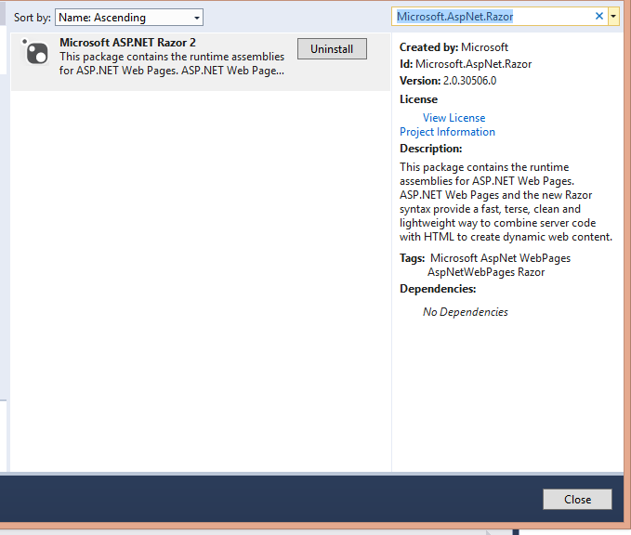

Microsoft.AspNet.WebPages

<http://www.nuget.org/packages/Microsoft.AspNet.WebPages/>

Install-Package Microsoft.AspNet.WebPages -Version 3.0.0

<package id="Microsoft.AspNet.WebPages" version="3.0.0" targetFramework="net45" />

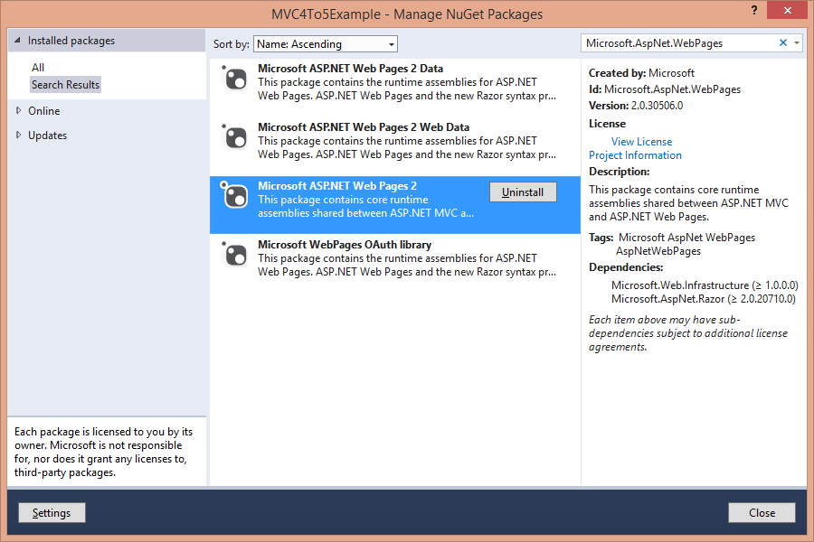

Microsoft.AspNet.WebPages.WebData

<http://www.nuget.org/packages/Microsoft.AspNet.WebPages.WebData/>

install-Package Microsoft.AspNet.WebPages.WebData -Version 3.0.0

<package id="Microsoft.AspNet.WebPages.Data" version="3.0.0" targetFramework="net40" />

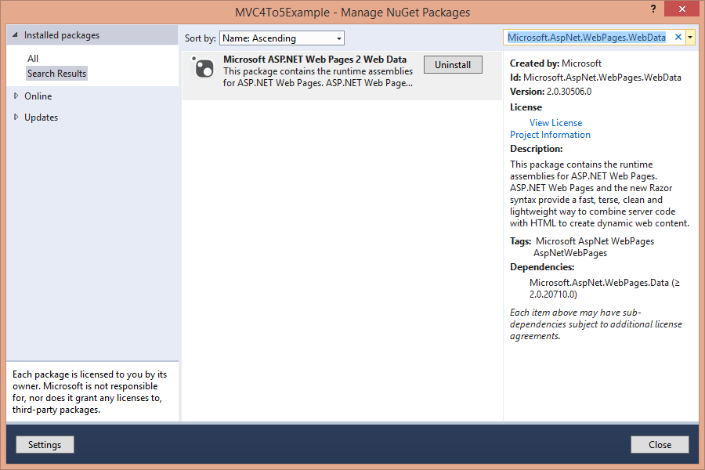

Microsoft.AspNet.WebPages.OAuth

<http://www.nuget.org/packages/Microsoft.AspNet.WebPages.OAuth/>

Install-Package Microsoft.AspNet.WebPages.OAuth -Version 3.0.0

<package id="Microsoft.AspNet.WebPages.OAuth" version="3.0.0" targetFramework="net45" />

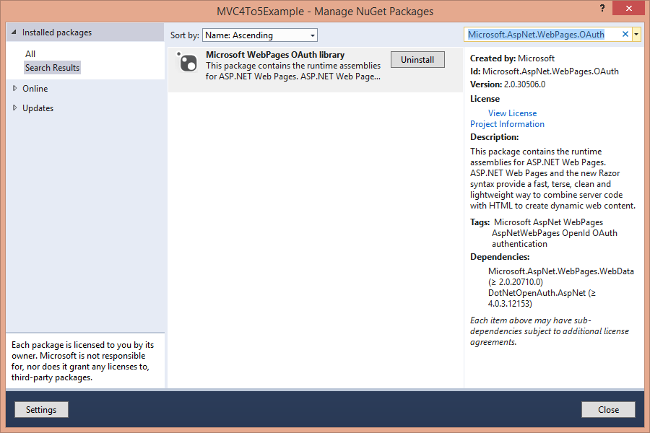

Microsoft.AspNet.Mvc

<http://www.nuget.org/packages/Microsoft.AspNet.Mvc/>

Install-Package Microsoft.AspNet.Mvc -Version 5.0.0

<package id="Microsoft.AspNet.Mvc" version="5.0.0" targetFramework="net45" />

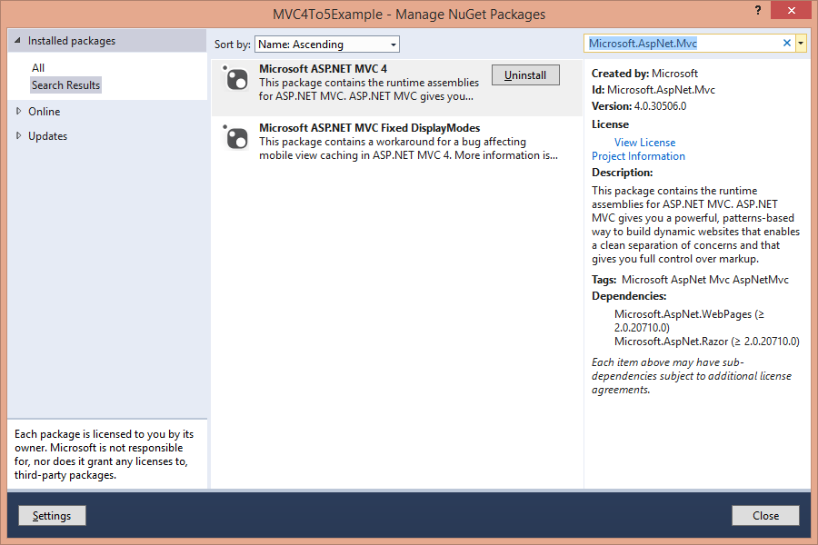

Microsoft.AspNet.Mvc.Facebook

<http://www.nuget.org/packages/Microsoft.AspNet.Mvc.Facebook/>

Install-Package Microsoft.AspNet.Mvc.Facebook

Microsoft.AspNet.WebApi.Core

<http://www.nuget.org/packages/Microsoft.AspNet.WebApi.Core/>

Install-Package Microsoft.AspNet.WebApi.Core -Version 5.0.0

<package id="Microsoft.AspNet.WebApi.Core" version="5.0.0" targetFramework="net45" />

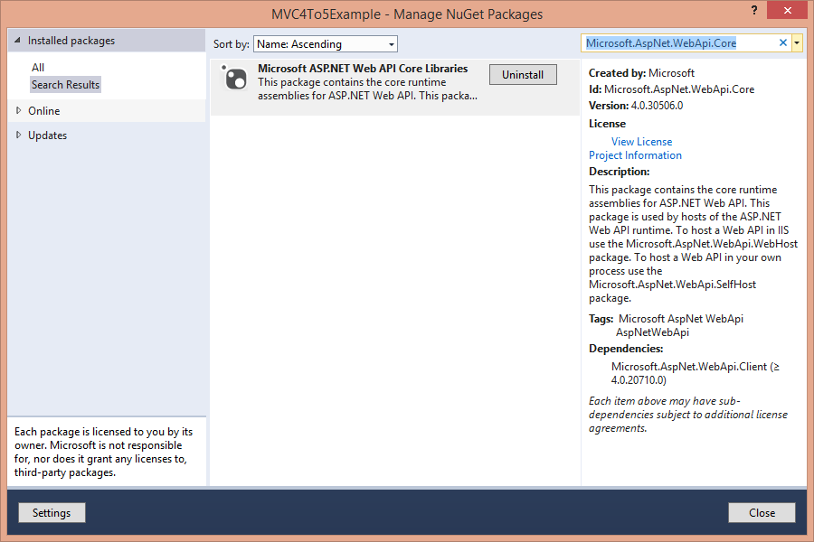

Microsoft.AspNet.WebApi.SelfHost

<http://www.nuget.org/packages/Microsoft.AspNet.WebApi.SelfHost/>

Install-Package Microsoft.AspNet.WebApi.SelfHost -Version 5.0.0

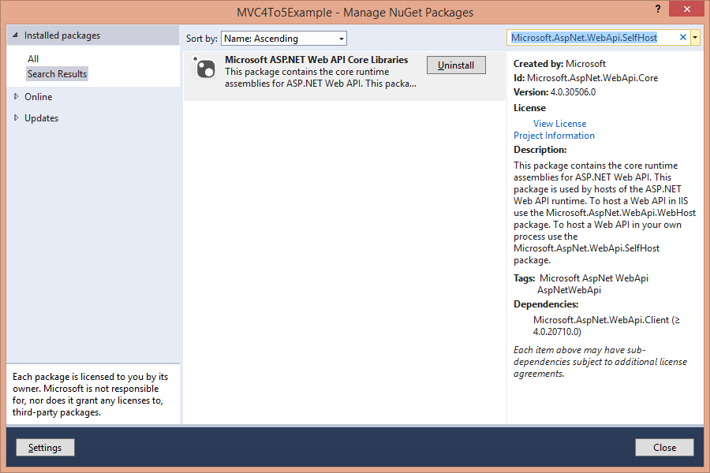

Microsoft.AspNet.WebApi.Client

<http://www.nuget.org/packages/Microsoft.AspNet.WebApi.Client/>

Install-Package Microsoft.AspNet.WebApi.Client -Version 5.0.0

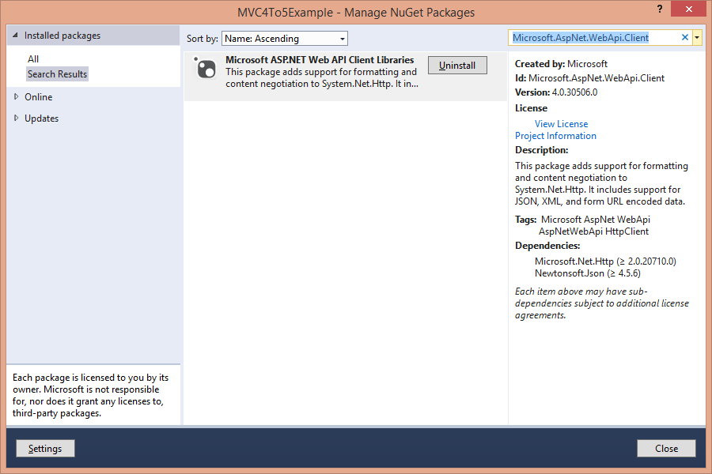

Microsoft.AspNet.WebApi.OData

<http://www.nuget.org/packages/Microsoft.AspNet.WebApi.OData/>

Install-Package Microsoft.AspNet.WebApi.OData -Version 5.0.0

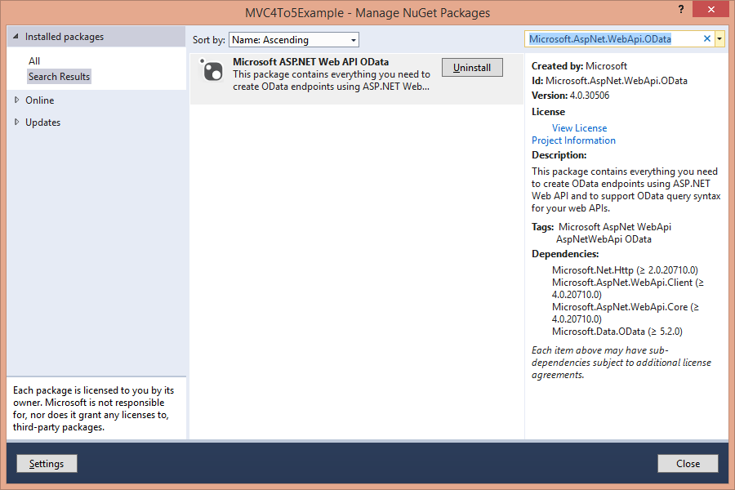

Microsoft.AspNet.WebApi

<http://www.nuget.org/packages/Microsoft.AspNet.WebApi/>

Install-Package Microsoft.AspNet.WebApi -Version 5.0.0

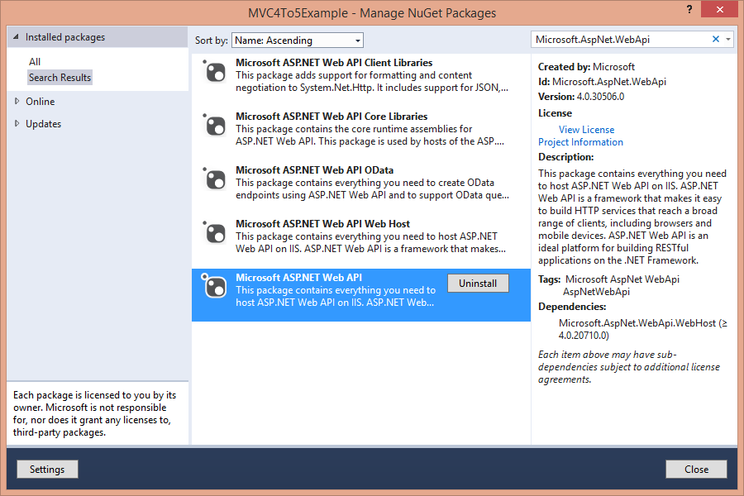

Microsoft.AspNet.WebApi.WebHost

<http://www.nuget.org/packages/Microsoft.AspNet.WebApi.WebHost/>

Install-Package Microsoft.AspNet.WebApi.WebHost -Version 5.0.0

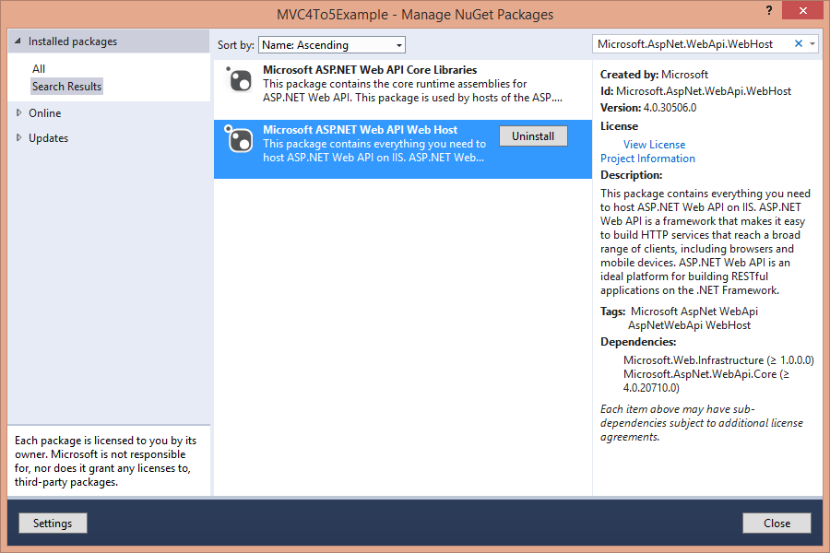

Microsoft.AspNet.WebApi.Tracing

<http://www.nuget.org/packages/Microsoft.AspNet.WebApi.Tracing/>

Install-Package Microsoft.AspNet.WebApi.Tracing -Version 5.0.0

Microsoft.AspNet.WebApi.HelpPage

<http://www.nuget.org/packages/Microsoft.AspNet.WebApi.HelpPage/>

Install-Package Microsoft.AspNet.WebApi.HelpPage -Version 5.0.0

Microsoft.Net.Http

<http://www.nuget.org/packages/Microsoft.Net.Http/>

Install-Package Microsoft.Net.Http -Version 2.2.20

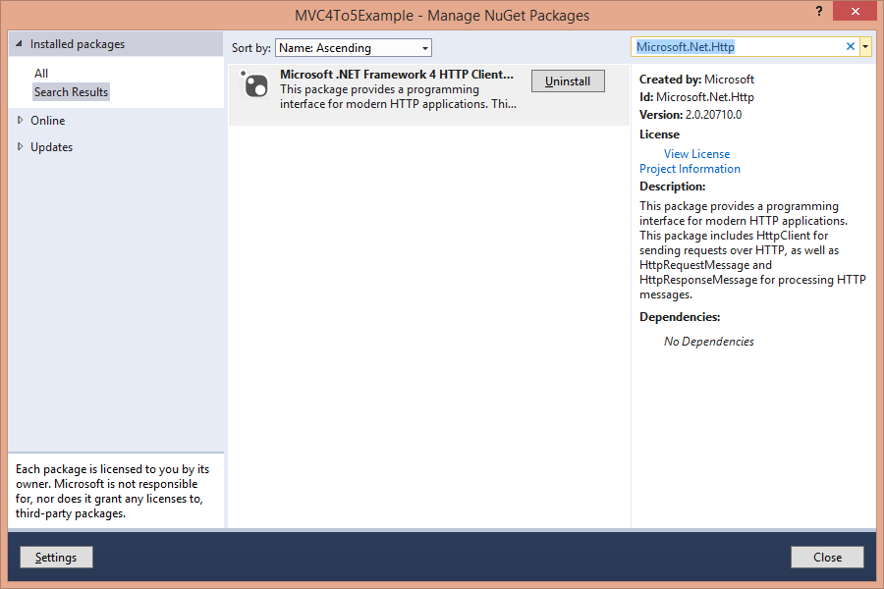

Microsoft.Data.OData

<http://www.nuget.org/packages/Microsoft.Data.OData/>

Install-Package Microsoft.Data.OData -Version 5.6.0

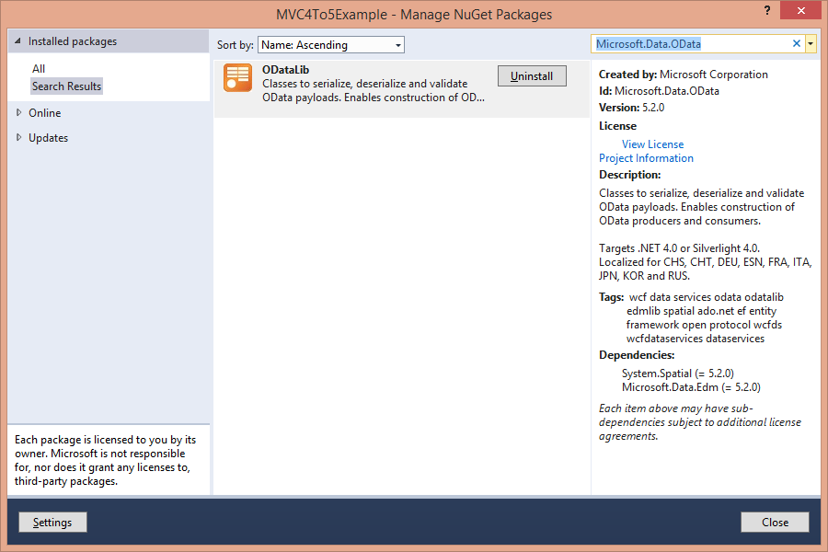

System.Spatial

<http://www.nuget.org/packages/System.Spatial/>

Install-Package System.Spatial -Version 5.6.0

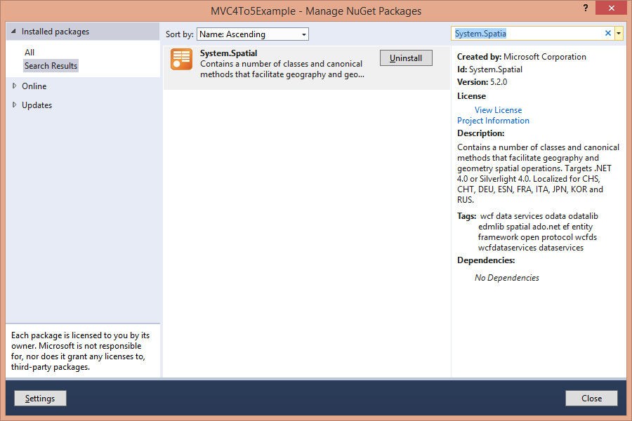

Microsoft.Data.Edm

<http://www.nuget.org/packages/Microsoft.Data.Edm/>

Install-Package Microsoft.Data.Edm -Version 5.6.0

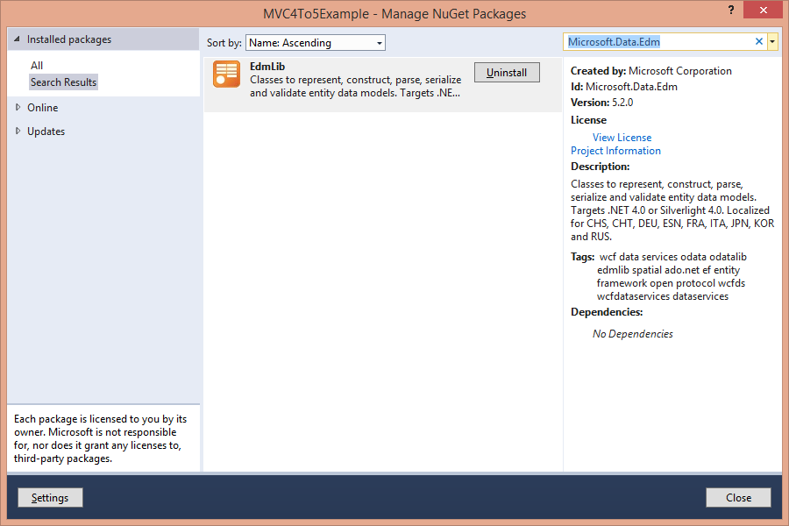

Microsoft.AspNet.Mvc.FixedDisplayModes

<http://www.nuget.org/packages/Microsoft.AspNet.Mvc.FixedDisplayModes/>

Uninstall-Package –ID Microsoft.AspNet.Mvc.FixedDisplayModes

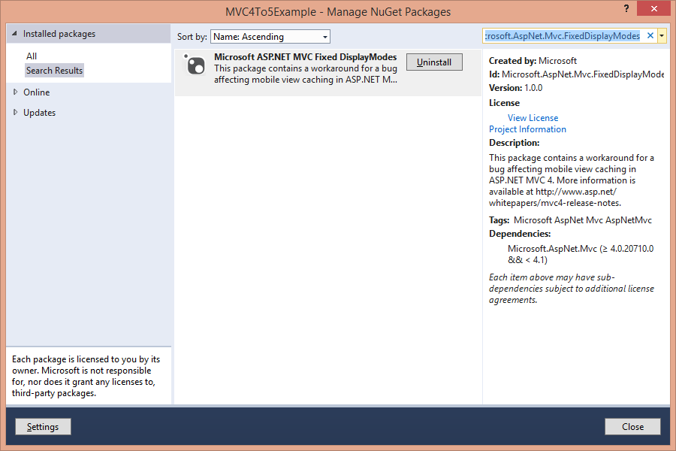

Microsoft.AspNet.WebPages.Administration

<http://www.nuget.org/packages/Microsoft.AspNet.WebPages.Administration/>

UnInstall-Package –ID Microsoft.AspNet.WebPages.Administration

Microsoft-Web-Helpers

<http://www.nuget.org/packages/Microsoft.AspNet.Web.Helpers.Mvc/>

Uninstall-Package -Id Microsoft-Web-Helpers

Install-Package Microsoft.AspNet.Web.Helpers.Mvc

